**SCHOOL**

**MANAGEMENT**

**SYSTEM**

**Introduction**

This is an automated software system written

in Python programming language for

**school management system** which can

store records of students and teachers.

Managing routine working-on manually has

always been daunting task for the

management team. Due to an apparent

lack of technology as a result the institute

begins to lag behind other institutes.

School management system is required

for success in everyday task.

The other feature of this management system

is file storage safety, easy access when

needed, data addition, deletion and modification.

**Abstract**

The main objective of the School Management

System which is developed in Python is to

provide easy access to the administration of the school. This system enables its users to add student's information, enter details, modify or delete student’s information, display

information of a particular student.

This helps the user to maintain the records systematically as it is impossible to manage so much of information manually.

This management system helps its users to keep the records in an ordered way and to manipulate them according to their use.

**USER DEFINED FUNCTIONS**

**def add_students( )**

This function provides the facility to get a student registered via the administration.

**def show_students()**

This function displays the information of all the students in the system.

**defupdate_students()**

This function allows the user to modify existing records of students.

**def remove_student( )**

This function removes the student’s record from the database.

**def add_teachers( )**

This function provides the facility to get a teacher registered via the administration.

**def show_teachers( )**

This function displays the information of all the teachers in the system.

**def update_teachers( )**

This function allows the user to modify existing records of teachers.

**def remove_teachers()**

This function removes the teacher’s record from the database.

**def add_marks()**

This functions allows a teacher to add marks of a student into the system and calculate the percentage.

**Hardware & Software**

**Requirement**

**Hardware Requirements:-**

* Minimum 512MB RAM (128 MB

desirable) at server.

* Minimum 100MB of free disk space for files.
* A CD ROM drive/ Pen Drive.
* Minimum of 48 MB of RAM at

Workstation.

**Software Requirements:-**

* Any Python IDE and Mysql 5.5 or above
* Windows 7 or above.

**How to Use**

This project is user friendly. It is completely menu driven with no complex input requirements. At each stage a menu has been designed with a number of options.

This School Management System has a very easy installation so that any user can access it easily.

It asks for desired input and displays its features. We can perform required tasks by the entering the respective choice.

**Menu Design**

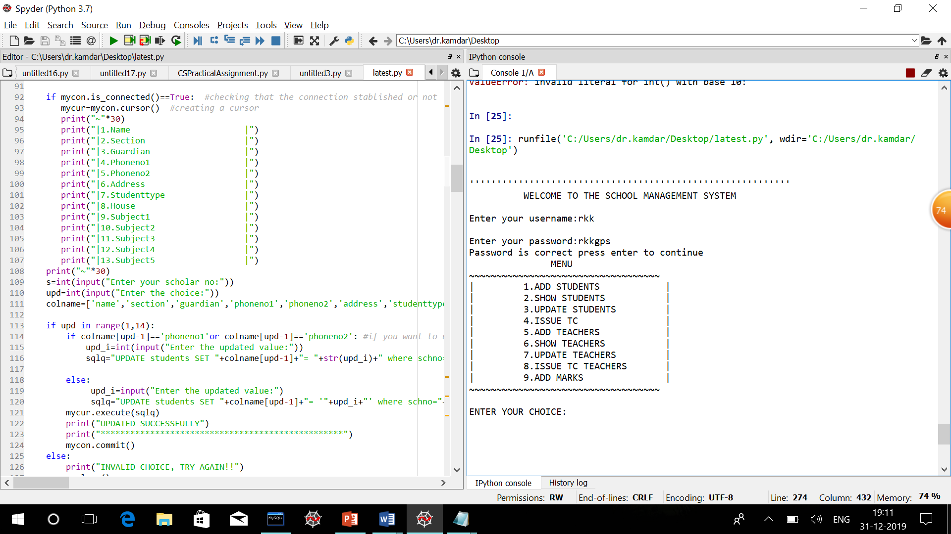

**Input \ Output Design**

To add a student into the management system–

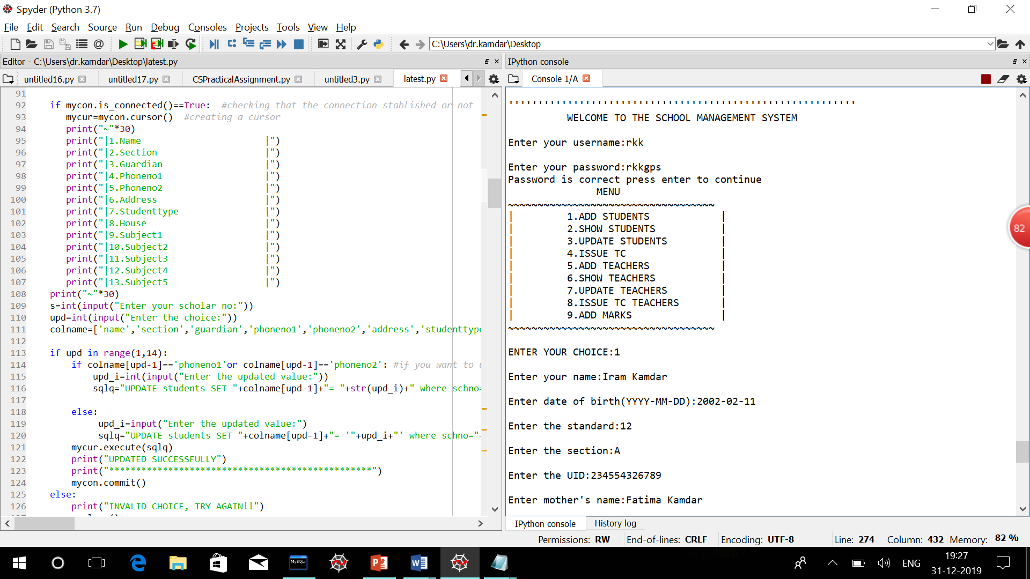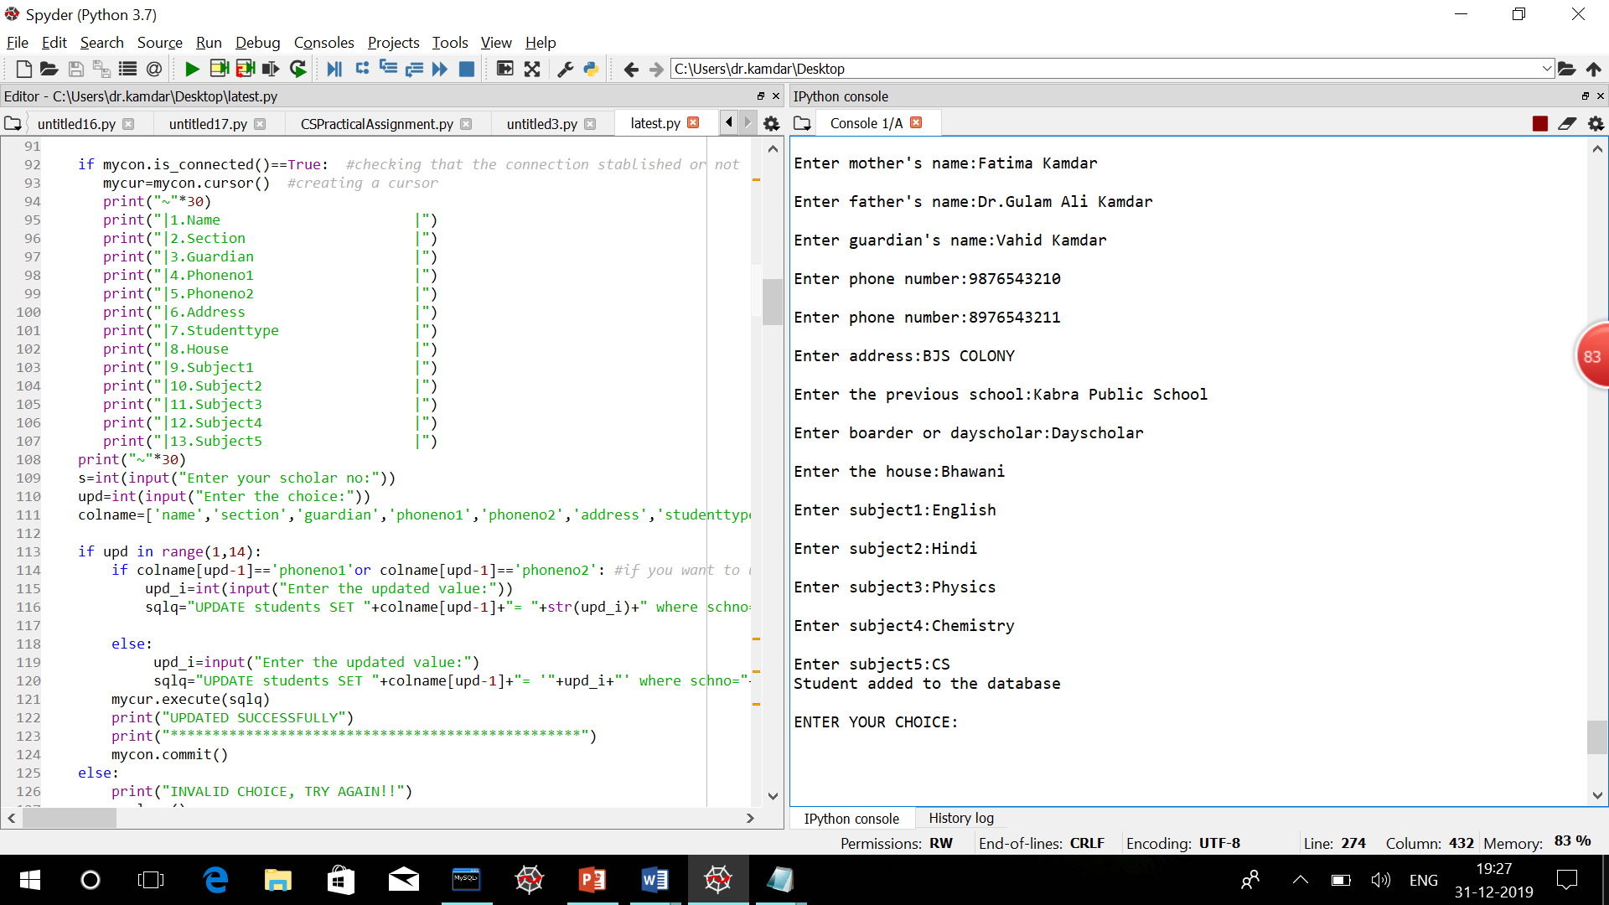

To show the record of a specific student -

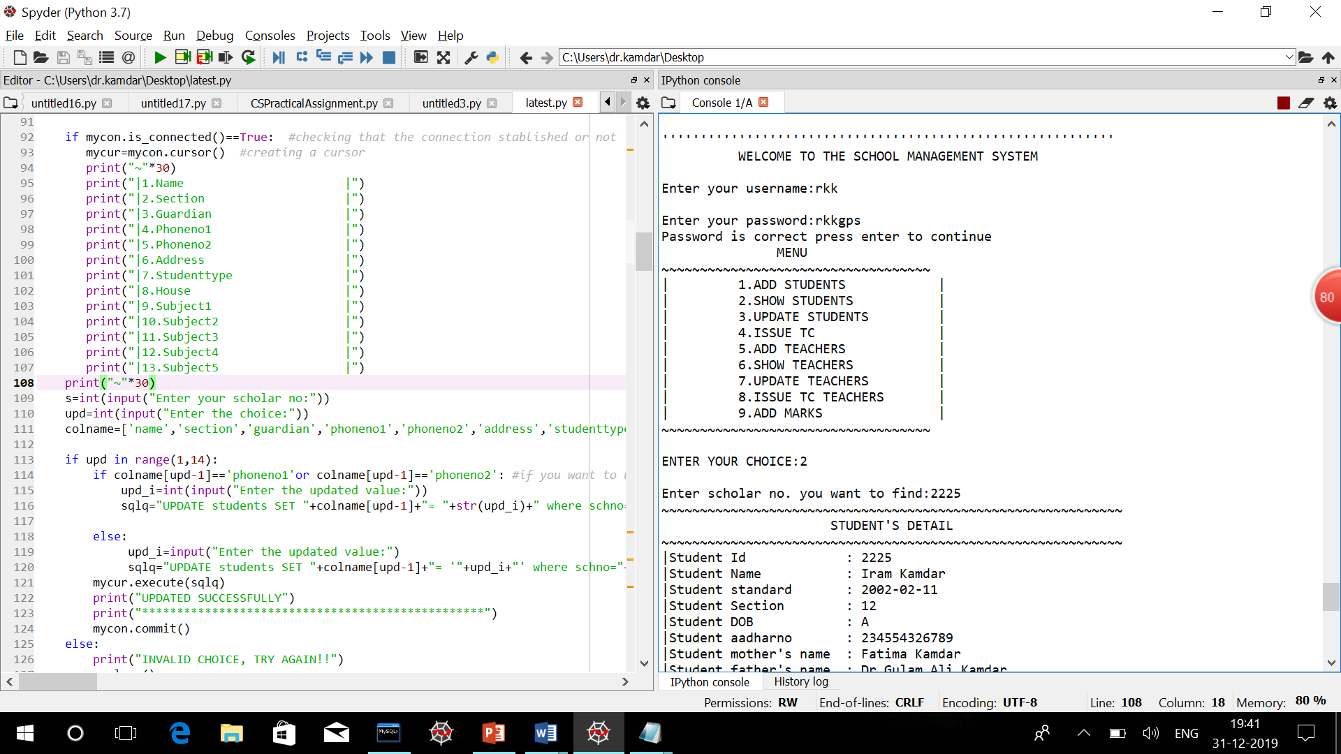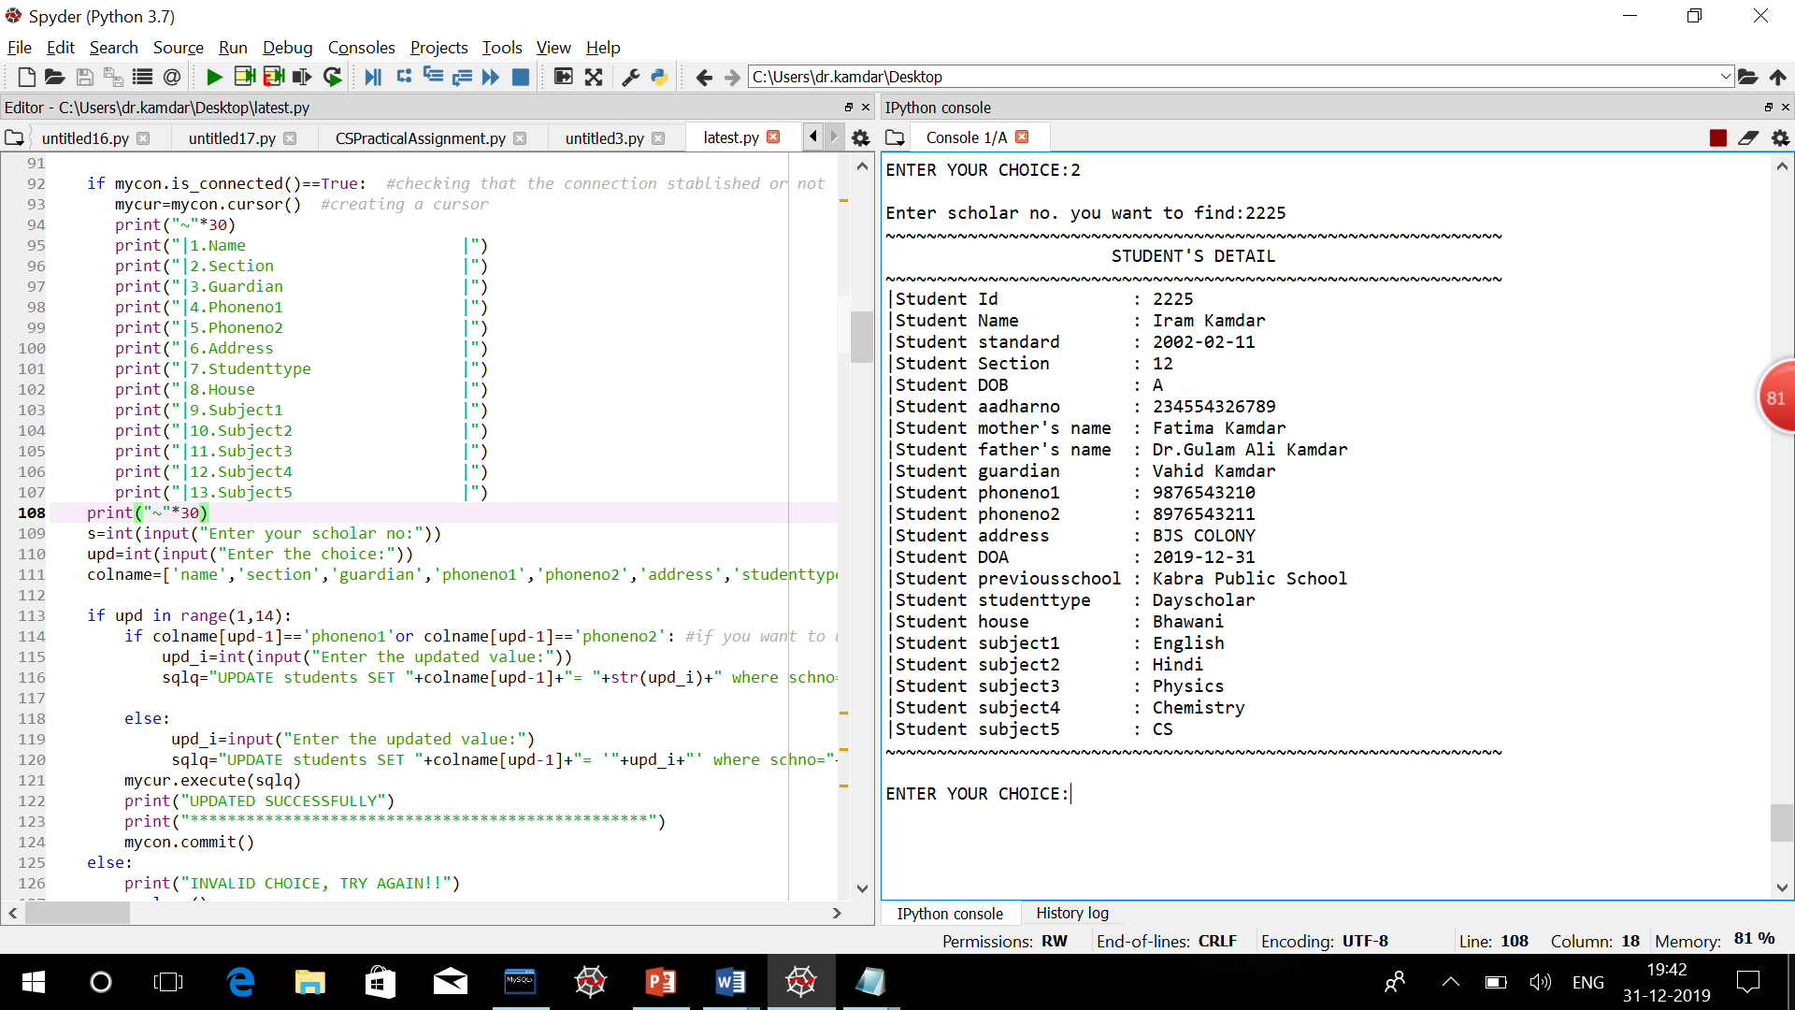

To update the record of a specific student-

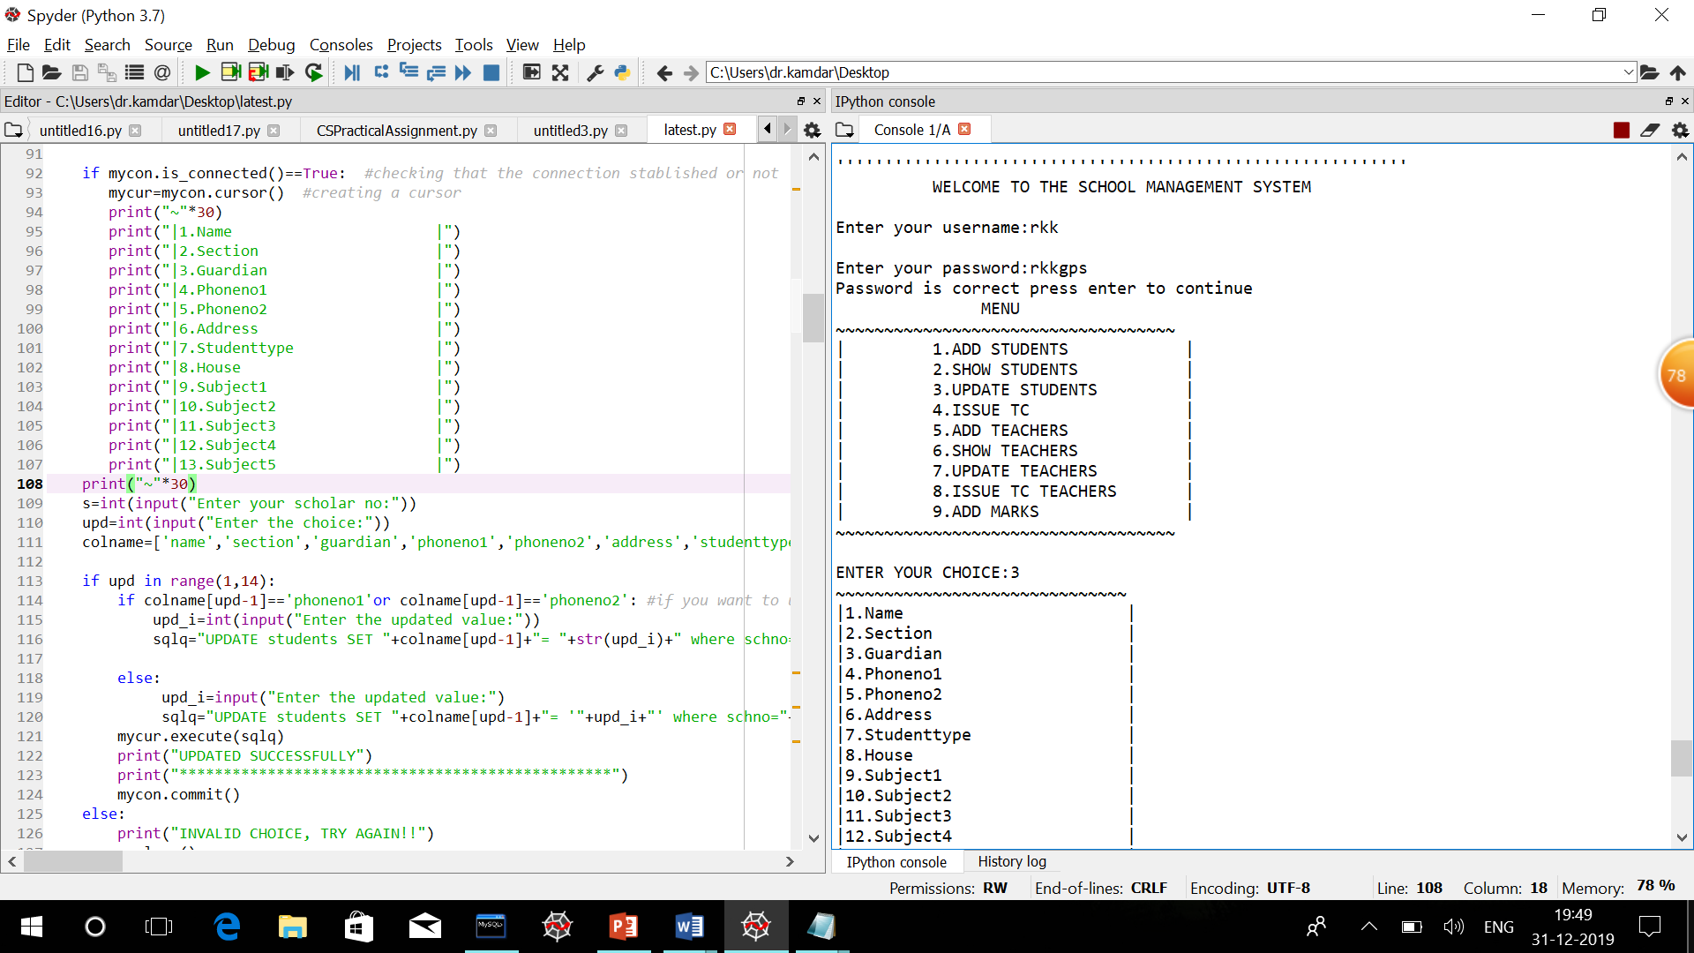

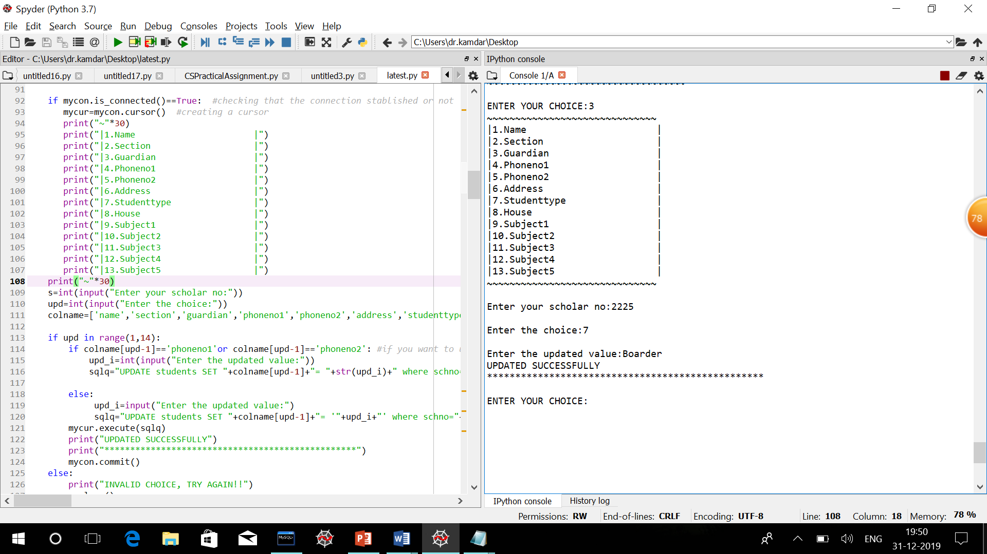

To remove a specific record of a student off the database –

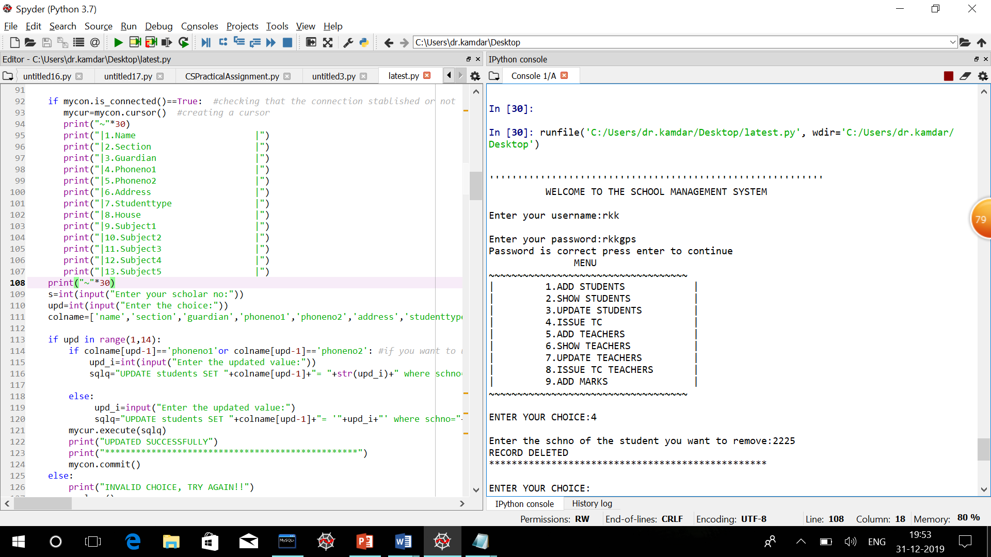

To remove a specific record of a teacher off the database –

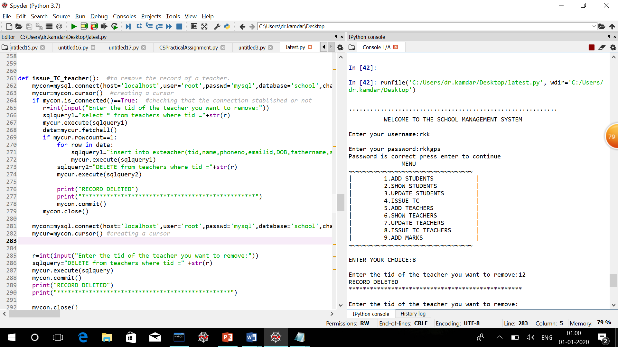

To add a teacher into the management system-

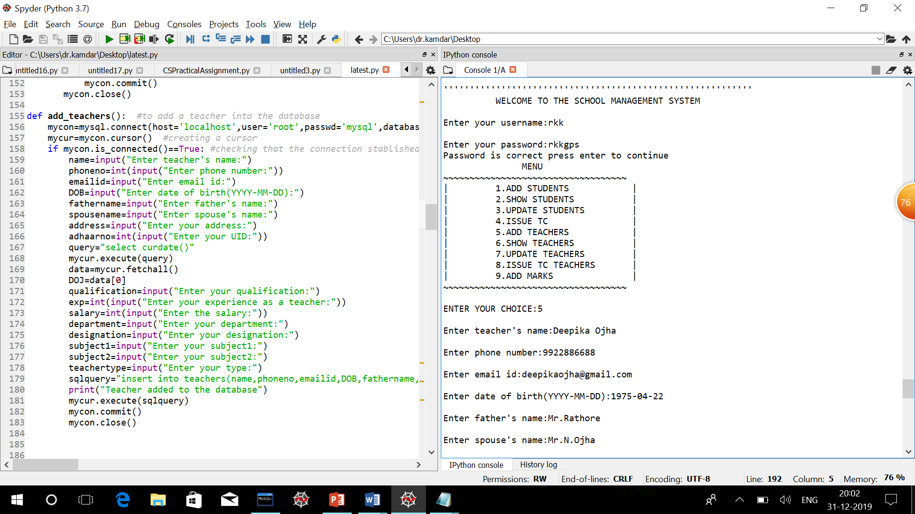

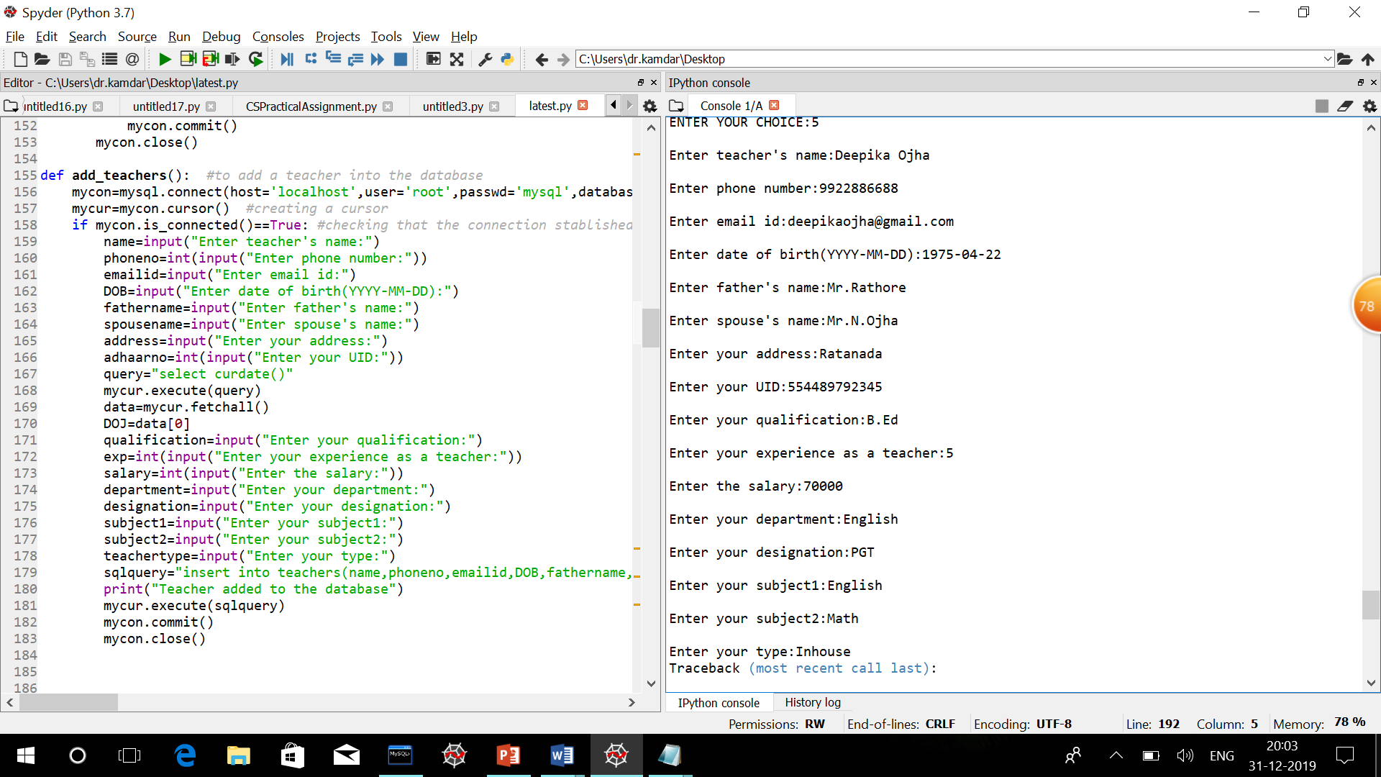

To update the record of a specific teacher-

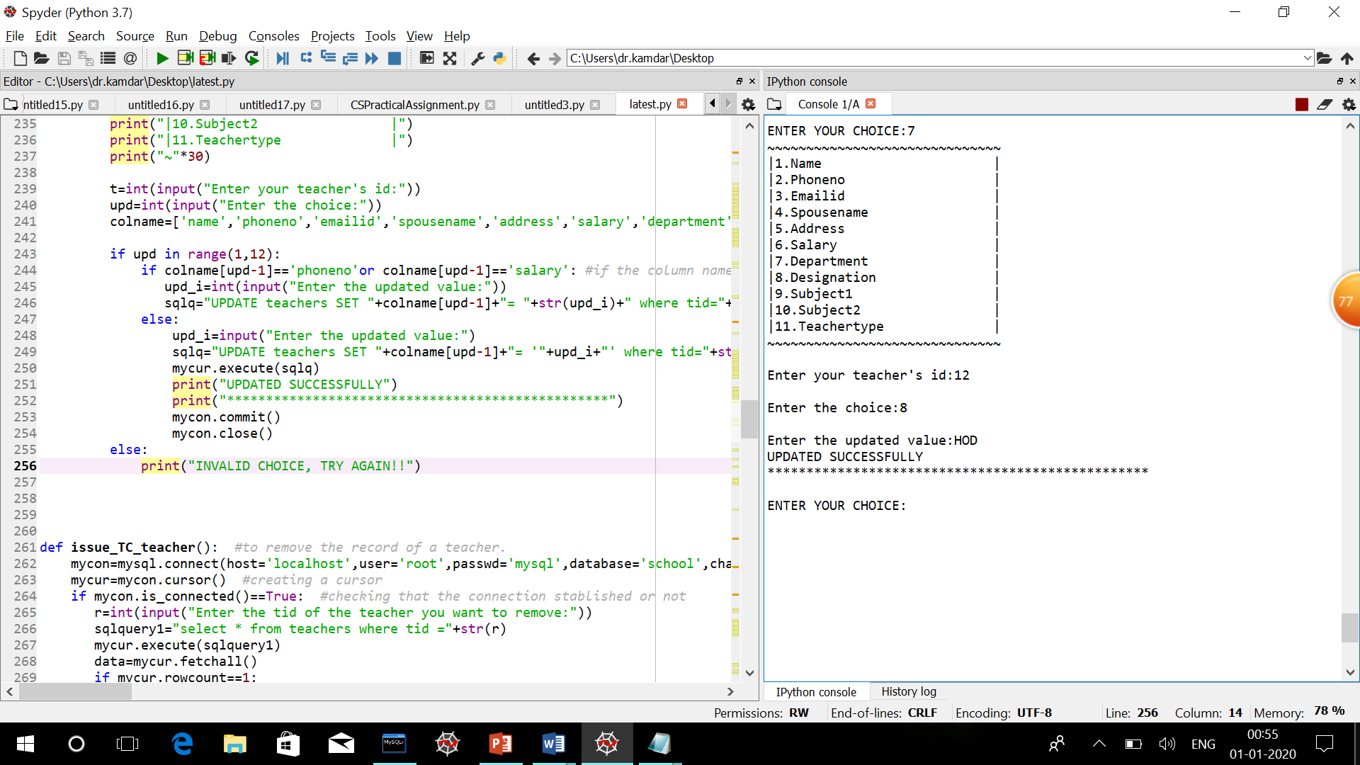

To show the record of a specific teacher-

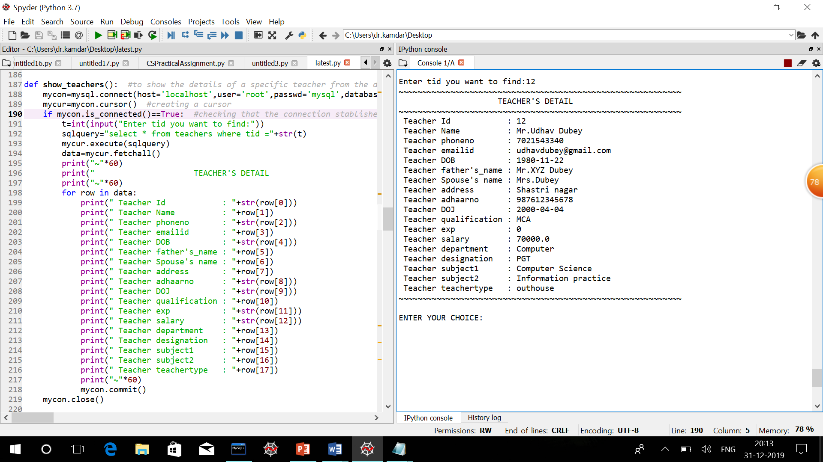

To add marks of students into the management system-



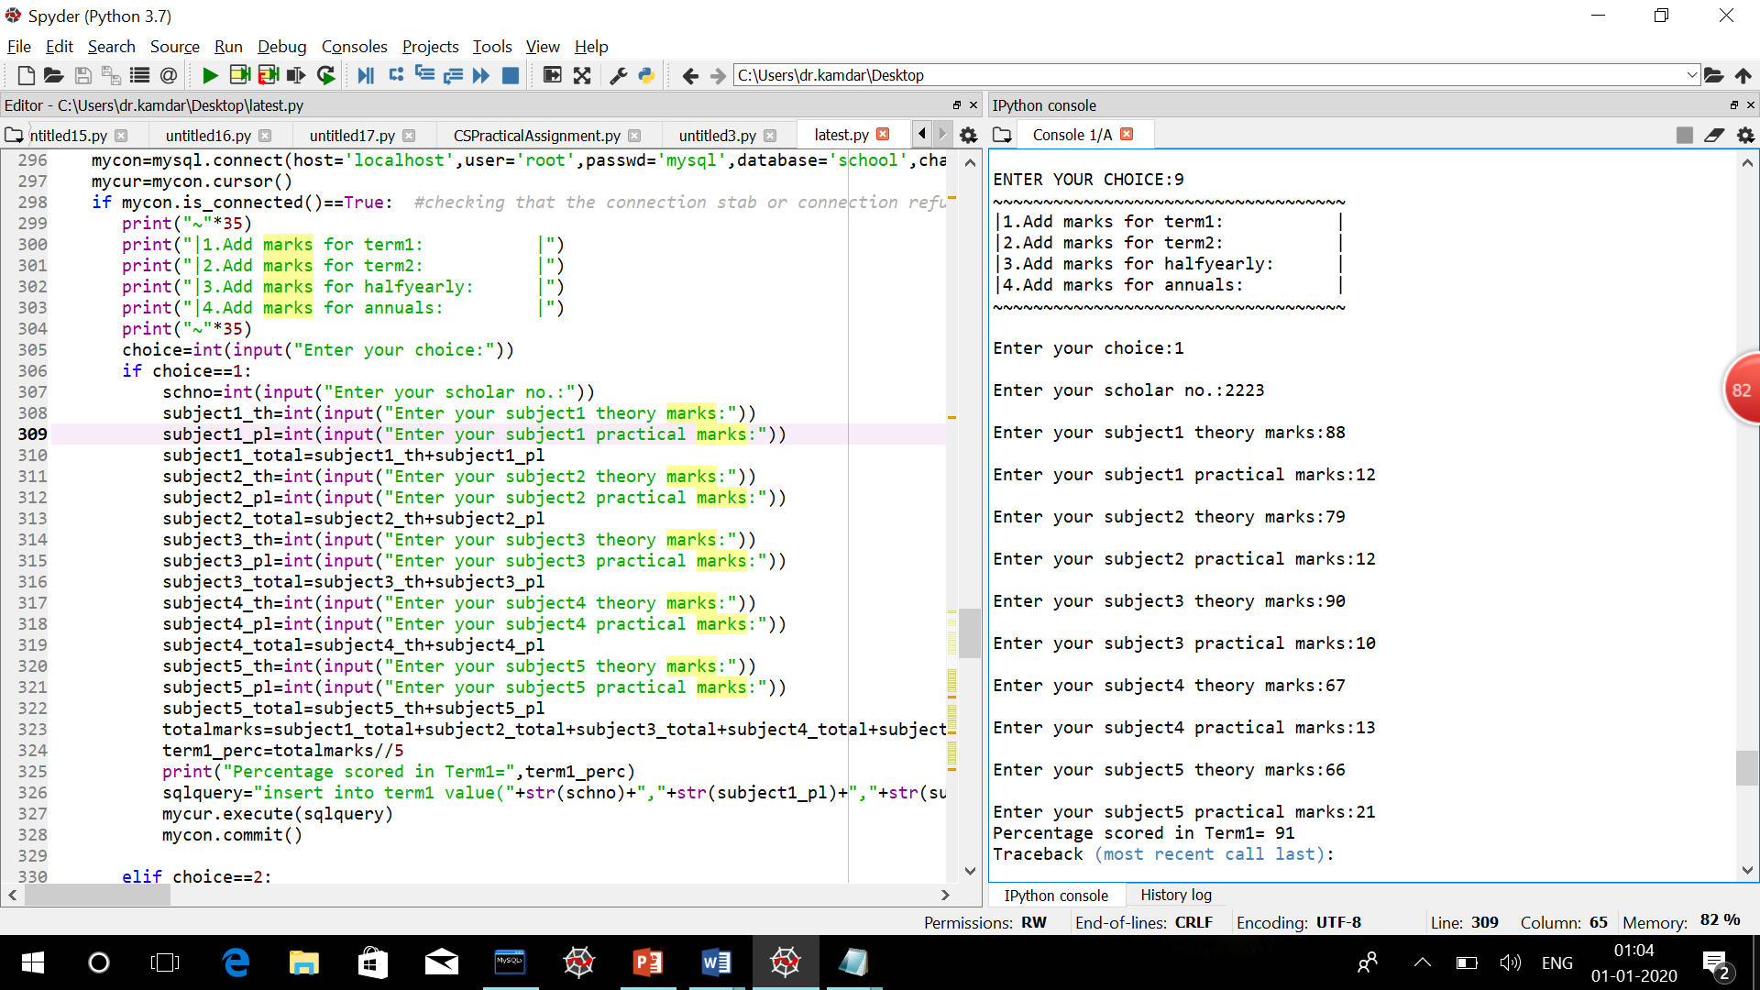

To form a marksheet of student-

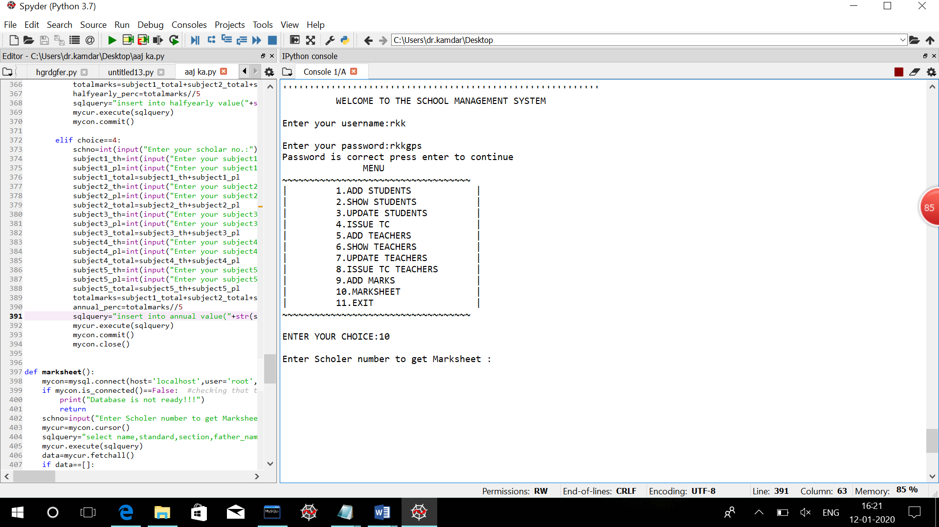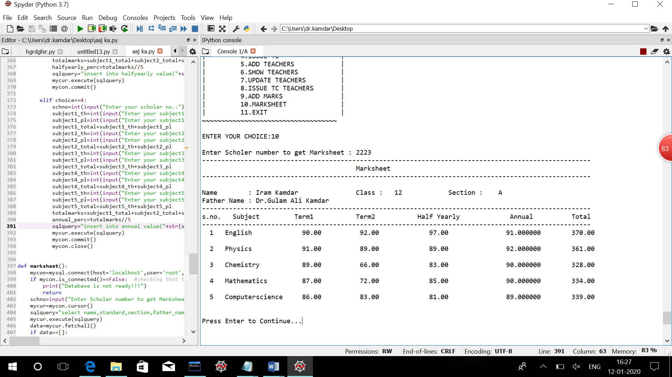

**Listing**

**(Source Code)**

import mysql.connector as mysql

def add_students(): #to add students into the database

mycon=mysql.connect(host='localhost',user='root',passwd='mysql',database='school',charset='utf8')

if mycon.is_connected()==True: #checking that the connection stablished or not

mycur=mycon.cursor() #creating a cursor

name=input("Enter your name:")

DOB=input("Enter date of birth(YYYY-MM-DD):")

standard=int(input("Enter the standard:"))

section=input("Enter the section:")

aadharno=input("Enter the UID:")

mother_name=input("Enter mother's name:")

father_name=input("Enter father's name:")

guardian=input("Enter guardian's name:")

phoneno1=int(input("Enter phone number:"))

phoneno2=int(input("Enter phone number:"))

address=input("Enter address:")

previousschool=input("Enter the previous school:")

studenttype=input("Enter boarder or dayscholar:")

house=input("Enter the house:")

subject1=input("Enter subject1:")

subject2=input("Enter subject2:")

subject3=input("Enter subject3:")

subject4=input("Enter subject4:")

subject5=input("Enter subject5:")

sqlquery="insert into students (name,DOB,standard,section,aadharno,mother_name,father_name,guardian,phoneno1,phoneno2,address,DOA,previousschool,studenttype,house,subject1,subject2,subject3,subject4,subject5)values('"+name+"','"+DOB+"',"+str(standard)+",'"+section+"','"+aadharno+"','"+mother_name+"','"+father_name+"','"+guardian+"',"+str(phoneno1)+","+str(phoneno2)+",'"+address+"',curdate(),'"+previousschool+"','"+studenttype+"','"+house+"','"+subject1+"','"+subject2+"','"+subject3+"','"+subject4+"','"+subject5+"')"

print("Student added to the database")

mycur.execute(sqlquery)

mycon.commit()

mycon.close()

else:("Database is not ready!!:(")

def show_students(): #to show the record of a specific student from the database

mycon=mysql.connect(host='localhost',user='root',passwd='mysql',database='school',charset='utf8')

if mycon.is_connected()==True: #checking that the connection stablished or not

mycur=mycon.cursor() #creating a cursor

s=int(input("Enter scholar no. you want to find:"))

sqlquery="select * from students where schno ="+str(s)

mycur.execute(sqlquery)

data=mycur.fetchall()

if mycur.rowcount==0:

print("NO RECORDS FOUND")

mycon.close()

return

print("~"*60)

print(" STUDENT'S DETAIL ")

print("~"*60)

for row in data:

print("|Student Id : "+str(row[0]))

print("|Student Name : "+row[1])

print("|Student standard : "+str(row[2]))

print("|Student Section : "+str(row[3]))

print("|Student DOB : "+str(row[4]))

print("|Student aadharno : "+row[5])

print("|Student mother's name : "+row[6])

print("|Student father's name : "+row[7])

print("|Student guardian : "+str(row[8]))

print("|Student phoneno1 : "+str(row[9]))

print("|Student phoneno2 : "+row[10])

print("|Student address : "+str(row[11]))

print("|Student DOA : "+str(row[12]))

print("|Student previousschool : "+row[13])

print("|Student studenttype : "+row[14])

print("|Student house : "+row[15])

print("|Student subject1 : "+row[16])

print("|Student subject2 : "+row[17])

print("|Student subject3 : "+row[18])

print("|Student subject4 : "+row[19])

print("|Student subject5 : "+row[20])

print("~"*60)

mycon.commit()

mycon.close()

def update_students(): #to update the records of a specific student.

mycon=mysql.connect(host='localhost',user='root',passwd='mysql',database='school',charset='utf8')

if mycon.is_connected()==True: #checking that the connection stablished or not

mycur=mycon.cursor() #creating a cursor

print("~"*30)

print("|1.Name |")

print("|2.Section |")

print("|3.Guardian |")

print("|4.Phoneno1 |")

print("|5.Phoneno2 |")

print("|6.Address |")

print("|7.Studenttype |")

print("|8.House |")

print("|9.Subject1 |")

print("|10.Subject2 |")

print("|11.Subject3 |")

print("|12.Subject4 |")

print("|13.Subject5 |")

print("~"*30)

s=int(input("Enter your scholar no:"))

upd=int(input("Enter the choice:"))

colname=['name','section','guardian','phoneno1','phoneno2','address','studenttype','house','subject1','subject2','subject3','subject4','subject5']

if upd in range(1,14):

if colname[upd-1]=='phoneno1'or colname[upd-1]=='phoneno2': #if you want to update integer type column

upd_i=int(input("Enter the updated value:"))

sqlq="UPDATE students SET "+colname[upd-1]+"= "+str(upd_i)+" where schno="+str(s)

else:

upd_i=input("Enter the updated value:")

sqlq="UPDATE students SET "+colname[upd-1]+"= '"+upd_i+"' where schno="+str(s)

mycur.execute(sqlq)

print("UPDATED SUCCESSFULLY")

print("*************************************************")

mycon.commit()

else:

print("INVALID CHOICE, TRY AGAIN!!")

mycon.close()

def issue_TC(): #to remove a student from the database.

mycon=mysql.connect(host='localhost',user='root',passwd='mysql',database='school',charset='utf8')

mycur=mycon.cursor() #creating a cursor

if mycon.is_connected()==True: #checking that the connection stablished or not

r=int(input("Enter the schno of the student you want to remove:"))

sqlquery1="select * from students where schno ="+str(r)

mycur.execute(sqlquery1)

data=mycur.fetchall()

if mycur.rowcount==1:

for row in data:

sqlquery1="insert into exstudents(schno,name,DOB,standard,section,aadharno,mother_name,father_name,guardian,phoneno1,phoneno2,address,DOA,previousschool,studenttype,house,subject1,subject2,subject3,subject4,subject5,tc_issue_date) values("+str(row[0])+",'"+str(row[1])+"','"+str(row[2])+"',"+str(row[3])+",'"+str(row[4])+"',"+str(row[5])+",'"+str(row[6])+"','"+str(row[7])+"','"+str(row[8])+"',"+str(row[9])+","+str(row[10])+",'"+str(row[11])+"','"+str(row[12])+"','"+str(row[13])+"','"+str(row[14])+"','"+str(row[15])+"','"+str(row[16])+"','"+str(row[17])+"','"+str(row[18])+"','"+str(row[19])+"','"+str(row[20])+"',curdate())"

mycur.execute(sqlquery1)

sqlquery2="DELETE from students where schno ="+str(r)

mycur.execute(sqlquery2)

print("RECORD DELETED")

print("*************************************************")

mycon.commit()

mycon.close()

def add_teachers(): #to add a teacher into the database

mycon=mysql.connect(host='localhost',user='root',passwd='mysql',database='school',charset='utf8')

mycur=mycon.cursor() #creating a cursor

if mycon.is_connected()==True: #checking that the connection stablished or not

name=input("Enter teacher's name:")

phoneno=int(input("Enter phone number:"))

emailid=input("Enter email id:")

DOB=input("Enter date of birth(YYYY-MM-DD):")

fathername=input("Enter father's name:")

spousename=input("Enter spouse's name:")

address=input("Enter your address:")

adhaarno=int(input("Enter your UID:"))

query="select curdate()"

mycur.execute(query)

data=mycur.fetchall()

DOJ=data[0]

qualification=input("Enter your qualification:")

exp=int(input("Enter your experience as a teacher:"))

salary=int(input("Enter the salary:"))

department=input("Enter your department:")

designation=input("Enter your designation:")

subject1=input("Enter your subject1:")

subject2=input("Enter your subject2:")

teachertype=input("Enter your type:")

sqlquery="insert into teachers(name,phoneno,emailid,DOB,fathername,spousename,address,adhaarno,doj,qualification,exp,salary,department,designation,subject1,subject2,teachertype) values("+"'"+name+"',"+str(phoneno)+",'"+emailid+"','"+DOB+"','"+fathername+"','"+spousename+"','"+address+"',"+str(adhaarno)+",curdate(),'"+qualification+"',"+str(exp)+","+str(salary)+",'"+department+"','"+designation+"','"+subject1+"','"+subject2+"','"+teachertype+"')"

print("Teacher added to the database")

mycur.execute(sqlquery)

mycon.commit()

mycon.close()

def show_teachers(): #to show the details of a specific teacher from the database.

mycon=mysql.connect(host='localhost',user='root',passwd='mysql',database='school',charset='utf8')

mycur=mycon.cursor() #creating a cursor

if mycon.is_connected()==True: #checking that the connection stablished or not

t=int(input("Enter tid you want to find:"))

sqlquery="select * from teachers where tid ="+str(t)

mycur.execute(sqlquery)

data=mycur.fetchall()

print("~"*60)

print(" TEACHER'S DETAIL ")

print("~"*60)

for row in data:

print(" Teacher Id : "+str(row[0]))

print(" Teacher Name : "+row[1])

print(" Teacher phoneno : "+str(row[2]))

print(" Teacher emailid : "+row[3])

print(" Teacher DOB : "+str(row[4]))

print(" Teacher father's_name : "+row[5])

print(" Teacher Spouse's name : "+row[6])

print(" Teacher address : "+row[7])

print(" Teacher adhaarno : "+str(row[8]))

print(" Teacher DOJ : "+str(row[9]))

print(" Teacher qualification : "+row[10])

print(" Teacher exp : "+str(row[11]))

print(" Teacher salary : "+str(row[12]))

print(" Teacher department : "+row[13])

print(" Teacher designation : "+row[14])

print(" Teacher subject1 : "+row[15])

print(" Teacher subject2 : "+row[16])

print(" Teacher teachertype : "+row[17])

print("~"*60)

mycon.commit()

mycon.close()

def update_teachers(): #to update records of a specific teacher.

mycon=mysql.connect(host='localhost',user='root',passwd='mysql',database='school',charset='utf8')

mycur=mycon.cursor() #creating a cursor

if mycon.is_connected()==True: #checking that the connection stablished or not

print("~"*30)

print("|1.Name |")

print("|2.Phoneno |")

print("|3.Emailid |")

print("|4.Spousename |")

print("|5.Address |")

print("|6.Salary |")

print("|7.Department |")

print("|8.Designation |")

print("|9.Subject1 |")

print("|10.Subject2 |")

print("|11.Teachertype |")

print("~"*30)

t=int(input("Enter your teacher's id:"))

upd=int(input("Enter the choice:"))

colname=['name','phoneno','emailid','spousename','address','salary','department','designation','subject1','subject2','teachertype']

if upd in range(1,12):

if colname[upd-1]=='phoneno'or colname[upd-1]=='salary': #if the column name you want to update is of inter type

upd_i=int(input("Enter the updated value:"))

sqlq="UPDATE teachers SET "+colname[upd-1]+"= "+str(upd_i)+" where tid="+str(t)

else:

upd_i=input("Enter the updated value:")

sqlq="UPDATE teachers SET "+colname[upd-1]+"= '"+upd_i+"' where tid="+str(t)

mycur.execute(sqlq)

print("UPDATED SUCCESSFULLY")

print("*************************************************")

mycon.commit()

mycon.close()

else:

print("INVALID CHOICE, TRY AGAIN!!")

def issue_TC_teacher(): #to remove the record of a teacher.

mycon=mysql.connect(host='localhost',user='root',passwd='mysql',database='school',charset='utf8')

mycur=mycon.cursor() #creating a cursor

if mycon.is_connected()==True: #checking that the connection stablished or not

r=int(input("Enter the tid of the teacher you want to remove:"))

sqlquery1="select * from teachers where tid ="+str(r)

mycur.execute(sqlquery1)

data=mycur.fetchall()

if mycur.rowcount==1:

for row in data:

sqlquery1="insert into exteacher(tid,name,phoneno,emailid,DOB,fathername,spousename,address,adhaarno,doj,qualification,exp,salary,department,designation,subject1,subject2,teachertype,tc_issue_date) values("+str(row[0])+",'"+str(row[1])+"',"+str(row[2])+",'"+str(row[3])+"','"+str(row[4])+"','"+str(row[5])+"','"+str(row[6])+"','"+str(row[7])+"',"+str(row[8])+",'"+str(row[9])+"','"+str(row[10])+"',"+str(row[11])+",'"+str(row[12])+"','"+str(row[13])+"','"+str(row[14])+"','"+str(row[15])+"','"+str(row[16])+"','"+str(row[17])+"',curdate())"

mycur.execute(sqlquery1)

sqlquery2="DELETE from teachers where tid ="+str(r)

mycur.execute(sqlquery2)

print("RECORD DELETED")

print("*************************************************")

mycon.commit()

mycon.close()

mycon=mysql.connect(host='localhost',user='root',passwd='mysql',database='school',charset='utf8')

mycur=mycon.cursor() #creating a cursor

r=int(input("Enter the tid of the teacher you want to remove:"))

sqlquery="DELETE from teachers where tid =" +str(r)

mycur.execute(sqlquery)

mycon.commit()

print("RECORD DELETED")

print("*************************************************")

mycon.close()

def add_marks(): #to add marks of student into the database

mycon=mysql.connect(host='localhost',user='root',passwd='mysql',database='school',charset='utf8')

mycur=mycon.cursor()

if mycon.is_connected()==True: #checking that the connection stab or connection refused by Database Server!!!")

print("~"*35)

print("|1.Add marks for term1: |")

print("|2.Add marks for term2: |")

print("|3.Add marks for halfyearly: |")

print("|4.Add marks for annuals: |")

print("~"*35)

choice=int(input("Enter your choice:"))

if choice==1:

schno=int(input("Enter your scholar no.:"))

subject1_th=int(input("Enter your subject1 theory marks:"))

subject1_pl=int(input("Enter your subject1 practical marks:"))

subject1_total=subject1_th+subject1_pl

subject2_th=int(input("Enter your subject2 theory marks:"))

subject2_pl=int(input("Enter your subject2 practical marks:"))

subject2_total=subject2_th+subject2_pl

subject3_th=int(input("Enter your subject3 theory marks:"))

subject3_pl=int(input("Enter your subject3 practical marks:"))

subject3_total=subject3_th+subject3_pl

subject4_th=int(input("Enter your subject4 theory marks:"))

subject4_pl=int(input("Enter your subject4 practical marks:"))

subject4_total=subject4_th+subject4_pl

subject5_th=int(input("Enter your subject5 theory marks:"))

subject5_pl=int(input("Enter your subject5 practical marks:"))

subject5_total=subject5_th+subject5_pl

totalmarks=subject1_total+subject2_total+subject3_total+subject4_total+subject5_total

term1_perc=totalmarks//5

print("Percentage scored in Term1=",term1_perc)

sqlquery="insert into term1 value("+str(schno)+","+str(subject1_pl)+","+str(subject1_th)+","+str(subject2_pl)+","+str(subject2_th)+","+str(subject3_pl)+","+str(subject3_th)+","+str(subject4_pl)+","+str(subject4_th)+","+str(subject5_pl)+","+str(subject5_th)+","+str(term1_perc)+")"

mycur.execute(sqlquery)

mycon.commit()

elif choice==2:

schno=int(input("Enter your scholar no.:"))

subject1_th=int(input("Enter your subject1 theory marks:"))

subject1_pl=int(input("Enter your subject1 marks:"))

subject1_total=subject1_th+subject1_pl

subject2_th=int(input("Enter your subject2 theory marks:"))

subject2_pl=int(input("Enter your subject2practical marks:"))

subject2_total=subject2_th+subject2_pl

subject3_th=int(input("Enter your subject3 theory marks:"))

subject3_pl=int(input("Enter your subject3 practical marks:"))

subject3_total=subject3_th+subject3_pl

subject4_th=int(input("Enter your subject4 theory marks:"))

subject4_pl=int(input("Enter your subject4 practical marks:"))

subject4_total=subject4_th+subject4_pl

subject5_th=int(input("Enter your subject5 theory marks:"))

subject5_pl=int(input("Enter your subject5 practical marks:"))

subject5_total=subject5_th+subject5_pl

totalmarks=subject1_total+subject2_total+subject3_total+subject4_total+subject5_total

term2_perc=totalmarks//5

sqlquery="insert into term2 value("+str(schno)+","+str(subject1_pl)+","+str(subject1_th)+","+str(subject2_pl)+","+str(subject2_th)+","+str(subject3_pl)+","+str(subject3_th)+","+str(subject4_pl)+","+str(subject4_th)+","+str(subject5_pl)+","+str(subject5_th)+","+str(term2_perc)+")"

mycur.execute(sqlquery)

mycon.commit()

elif choice==3:

schno=int(input("Enter your scholar no.:"))

subject1_th=int(input("Enter your subject1 theory marks:"))

subject1_pl=int(input("Enter your subject1 marks:"))

subject1_total=subject1_th+subject1_pl

subject2_th=int(input("Enter your subject2 theory marks:"))

subject2_pl=int(input("Enter your subject2practical marks:"))

subject2_total=subject2_th+subject2_pl

subject3_th=int(input("Enter your subject3 theory marks:"))

subject3_pl=int(input("Enter your subject3 practical marks:"))

subject3_total=subject3_th+subject3_pl

subject4_th=int(input("Enter your subject4 theory marks:"))

subject4_pl=int(input("Enter your subject4 practical marks:"))

subject4_total=subject4_th+subject4_pl

subject5_th=int(input("Enter your subject5 theory marks:"))

subject5_pl=int(input("Enter your subject5 practical marks:"))

subject5_total=subject5_th+subject5_pl

totalmarks=subject1_total+subject2_total+subject3_total+subject4_total+subject5_total

halfyearly_perc=totalmarks//5

sqlquery="insert into halfyearly value("+str(schno)+","+str(subject1_pl)+","+str(subject1_th)+","+str(subject2_pl)+","+str(subject2_th)+","+str(subject3_pl)+","+str(subject3_th)+","+str(subject4_pl)+","+str(subject4_th)+","+str(subject5_pl)+","+str(subject5_th)+","+str(halfyearly_perc)+")"

mycur.execute(sqlquery)

mycon.commit()

elif choice==4:

schno=int(input("Enter your scholar no.:"))

subject1_th=int(input("Enter your subject1 theory marks:"))

subject1_pl=int(input("Enter your subject1 marks:"))

subject1_total=subject1_th+subject1_pl

subject2_th=int(input("Enter your subject2 theory marks:"))

subject2_pl=int(input("Enter your subject2practical marks:"))

subject2_total=subject2_th+subject2_pl

subject3_th=int(input("Enter your subject3 theory marks:"))

subject3_pl=int(input("Enter your subject3 practical marks:"))

subject3_total=subject3_th+subject3_pl

subject4_th=int(input("Enter your subject4 theory marks:"))

subject4_pl=int(input("Enter your subject4 practical marks:"))

subject4_total=subject4_th+subject4_pl

subject5_th=int(input("Enter your subject5 theory marks:"))

subject5_pl=int(input("Enter your subject5 practical marks:"))

subject5_total=subject5_th+subject5_pl

totalmarks=subject1_total+subject2_total+subject3_total+subject4_total+subject5_total

annual_perc=totalmarks//5

sqlquery="insert into annual value("+str(schno)+","+str(subject1_pl)+","+str(subject1_th)+","+str(subject2_pl)+","+str(subject2_th)+","+str(subject3_pl)+","+str(subject3_th)+","+str(subject4_pl)+","+str(subject4_th)+","+str(subject5_pl)+","+str(subject5_th)+","+str(annual_perc)+")"

mycur.execute(sqlquery)

mycon.commit()

mycon.close()

def marksheet():

mycon=mysql.connect(host='localhost',user='root',passwd='mysql',database='school',charset='utf8')

if mycon.is_connected()==False: #checking that the connection stab or connection refused by Database Server!!!")

print("Database is not ready!!!")

return

schno=input("Enter Scholar number to get Marksheet : ")

mycur=mycon.cursor()

sqlquery="select name,standard,section,father_name,subject1,subject2,subject3,subject4,subject5,t1.*,t2.*,t3.*,t4.* from students s,term1 t1,term2 t2,halfyearly t3,annual t4 where s.schno=t1.schno and s.schno=t2.schno and s.schno=t3.schno and s.schno=t4.schno and s.schno="+schno

mycur.execute(sqlquery)

data=mycur.fetchall()

if data==[]:

print("Student not found or still all exams are not given!!!")

input("Press Enter to continue...")

return

name=data[0][0]

standard=data[0][1]

section=data[0][2]

fname=data[0][3]

print("-"*101)

print("\t\t\t\t\tMarksheet")

print("-"*101)

print()

print("Name : {0:<25s}".format(name),end=" ")

print("Class : {0:>4d}".format(standard),end=" ")

print("\t\tSection : {0:>4s}".format(section))

print("Father Name : {0:<25s}".format(fname))

print("-"*101)

print("s.no.\tSubject\t\tTerm1\t\tTerm2\t\tHalf Yearly\t\tAnnual\t\tTotal")

print("-"*101)

for i in range(4,9):

sno=i-3

subject=data[0][i]

t1sub=int(data[0][6+i])+int(data[0][7+i])

t2sub=int(data[0][6+12+i])+int(data[0][7+12+i])

t3sub=int(data[0][6+12+12+i])+int(data[0][7+12+12+i])

t4sub=int(data[0][6+12+12+12+i])+int(data[0][7+12+12+12+i])

gtotal=t1sub+t2sub+t3sub+t4sub

print("{0:>3d} {1:<20s}{2:>4.2f}{3:>15.2f}{4:>18.2f}{5:>24f}{6:>14.2f}".format(sno,subject,t1sub,t2sub,t3sub,t4sub,gtotal))

print()

input("Press Enter to Continue...")

mycon.close()

#main

print("\n")

print("'''''''''''''''''''''''''''''''''''''''''''''''''''''''''''")

print(" WELCOME TO THE SCHOOL MANAGEMENT SYSTEM ")

username=input("Enter your username:")

password=input("Enter your password:")

correct_username='rkk'

correct_password='rkkgps'

if username==correct_username:

if password==correct_password:

print("Password is correct press enter to continue")

ch=0

while ch!=11:

print(" MENU ")

print("~"*35)

print("| 1.ADD STUDENTS |")

print("| 2.SHOW STUDENTS |")

print("| 3.UPDATE STUDENTS |")

print("| 4.ISSUE TC |")

print("| 5.ADD TEACHERS |")

print("| 6.SHOW TEACHERS |")

print("| 7.UPDATE TEACHERS |")

print("| 8.ISSUE TC TEACHERS |")

print("| 9.ADD MARKS |")

print("| 10.MARKSHEET |")

print("| 11.EXIT |")

print("~"*35)

ch=int(input("ENTER YOUR CHOICE:"))

if ch==1:

add_students()

elif ch==2:

show_students()

elif ch==3:

update_students()

elif ch==4:

issue_TC()

elif ch==5:

add_teachers()

elif ch==6:

show_teachers()

elif ch==7:

update_teachers()

elif ch==8:

issue_TC_teacher()

elif ch==9:

add_marks()

elif ch==10:

marksheet()

elif ch==11:

print("This program is devloped by Iram Kamdar :)")

else:

print("~"*30)

print("INVALID CHOICES")

print("~"*30)

input("press Enter to bye bye.....")

else:

print('Password incorrect')

else:

print('User does not exist')

print('Access denied')

**Data Dictionary**

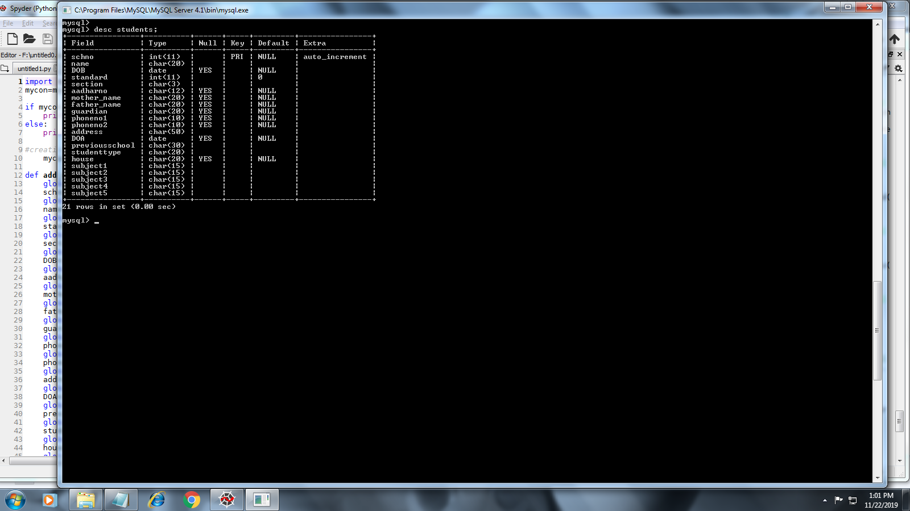

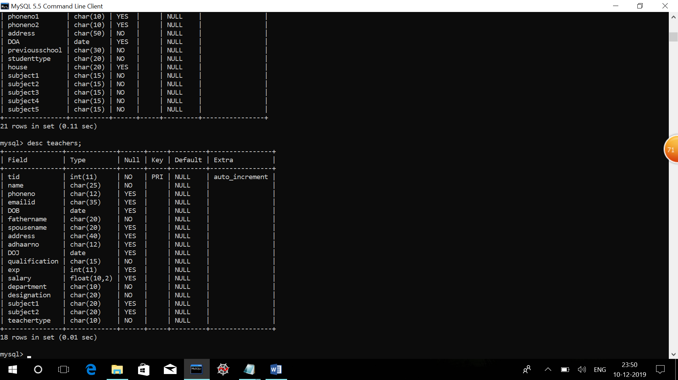

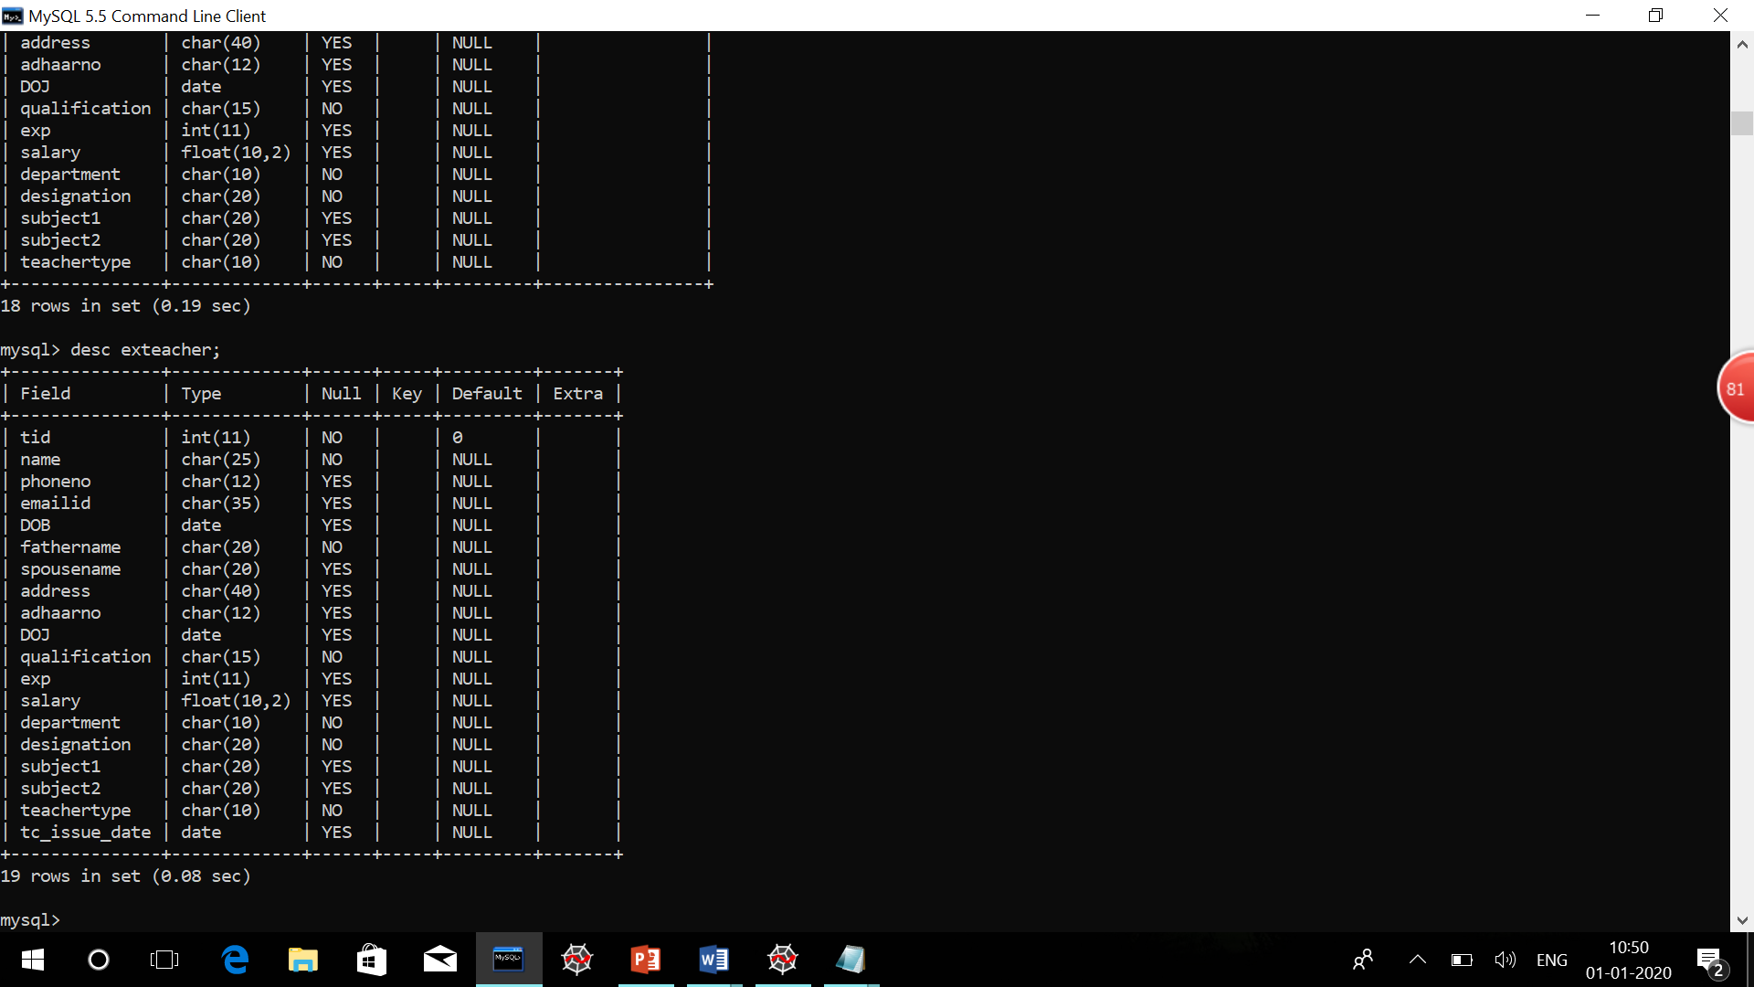

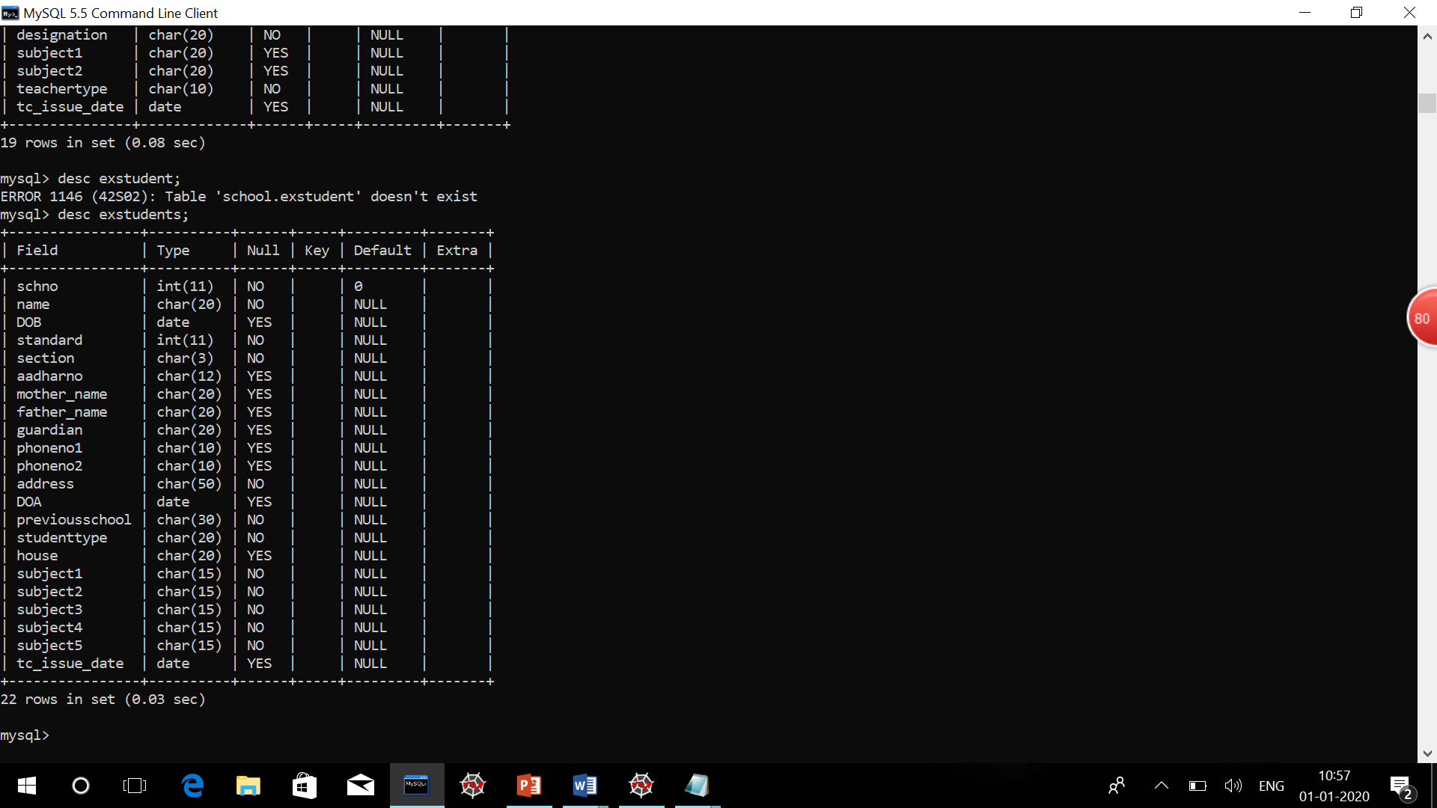

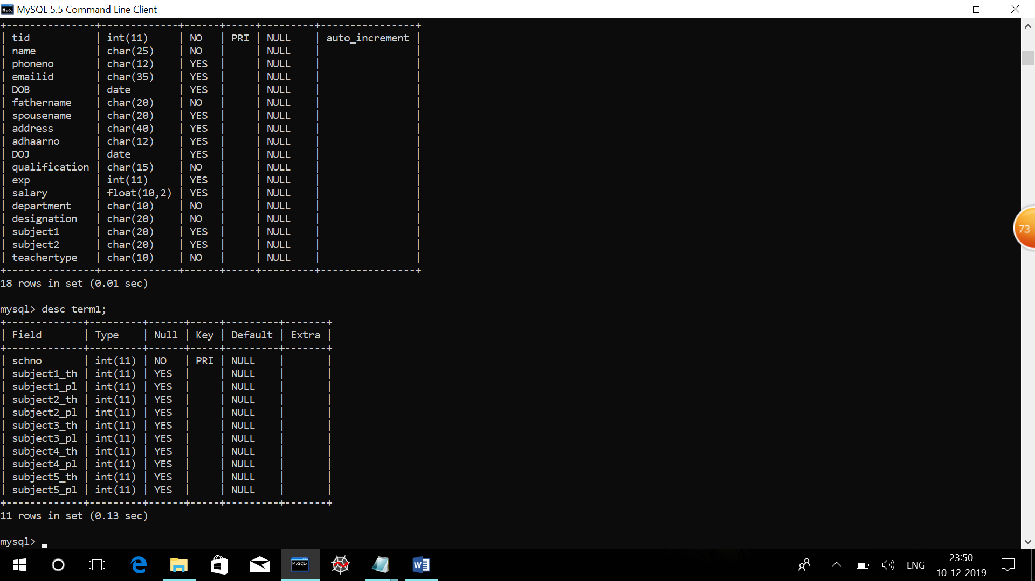

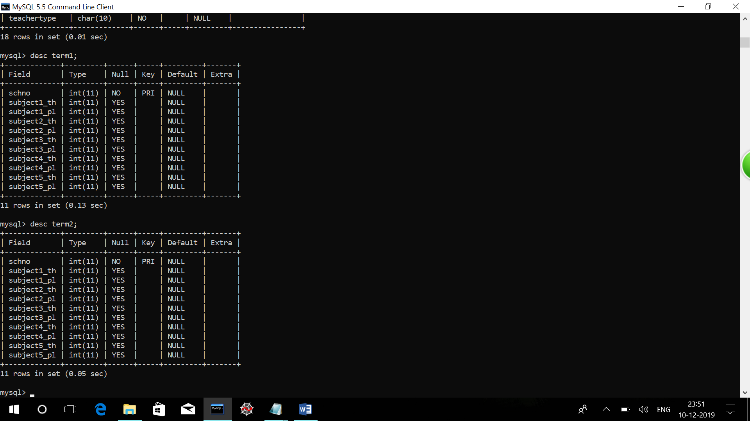

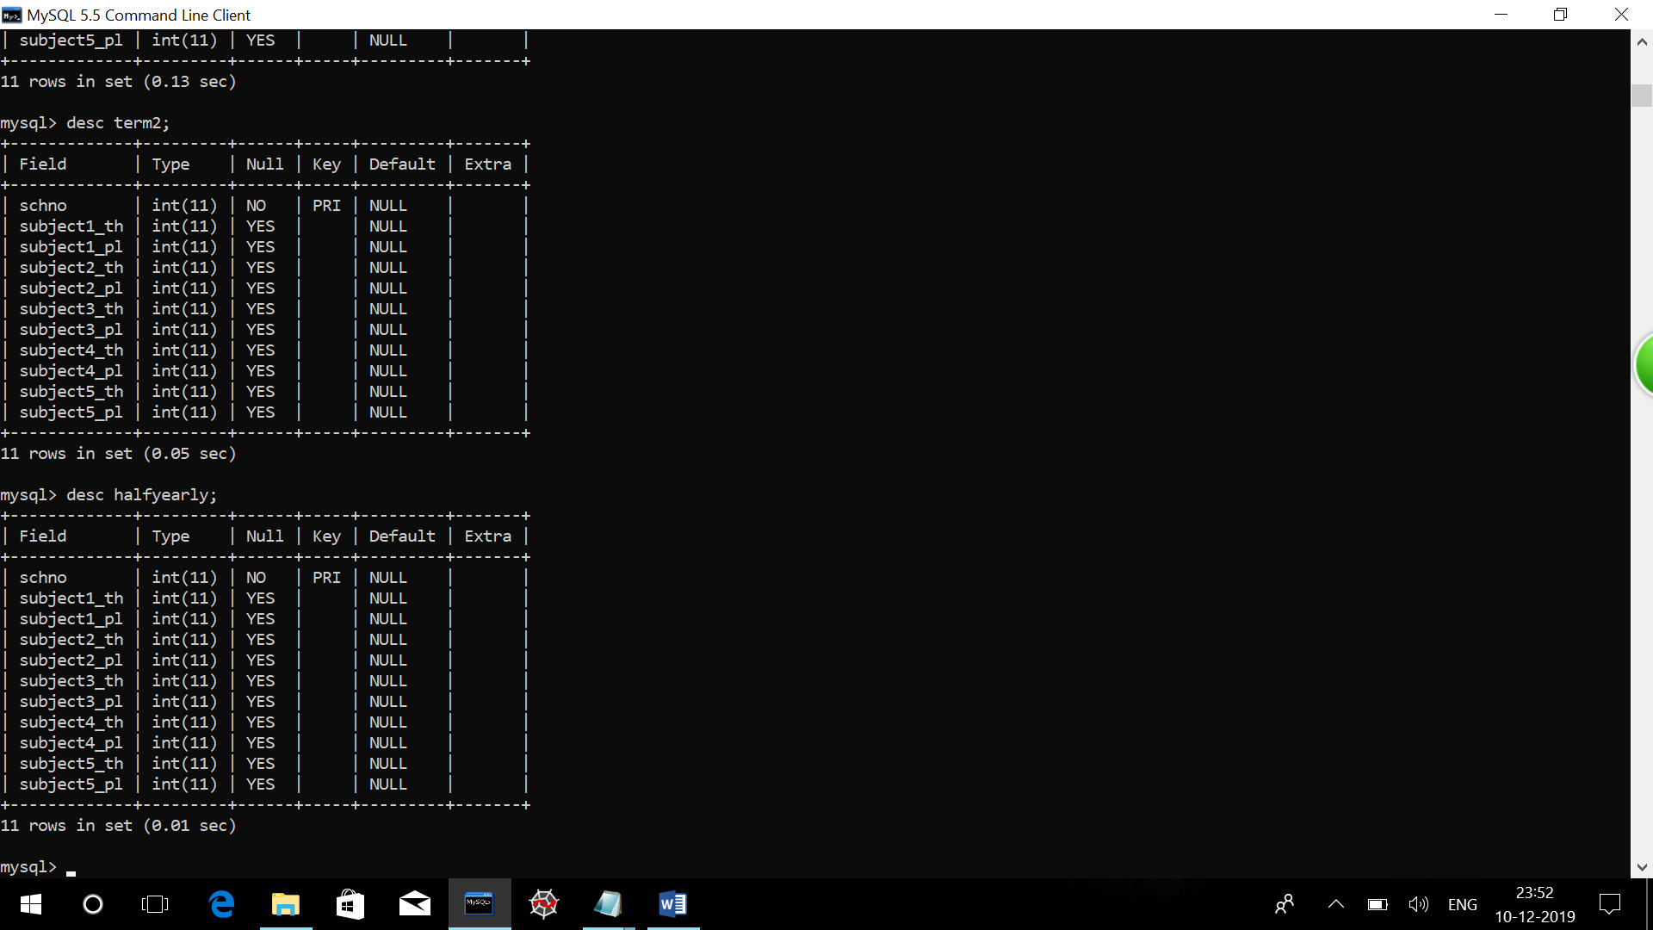

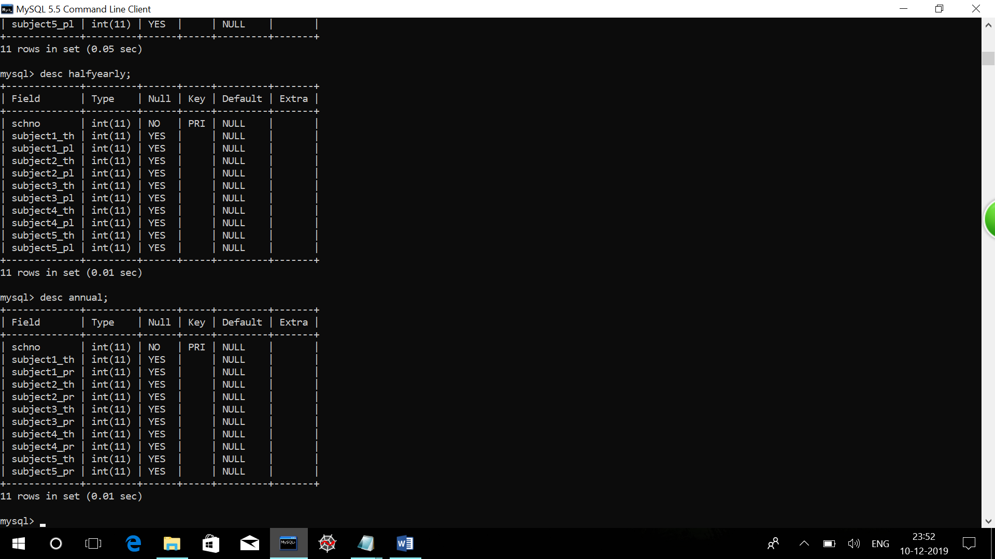

**LIMITATIONS AND ENHANCEMENT:**

* The project cannot be made online because of the limitations of the

language.

* The password is server oriented that means it cannot be changed by the user.

**Bibliography**

* Sumita Arora Python Class 11
* Sumita Arora Python Class 12